

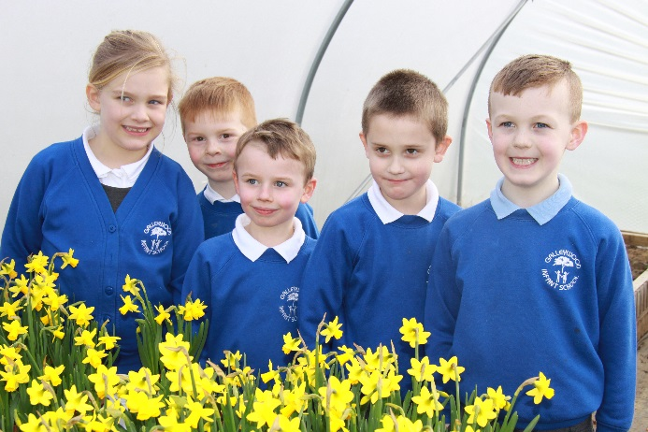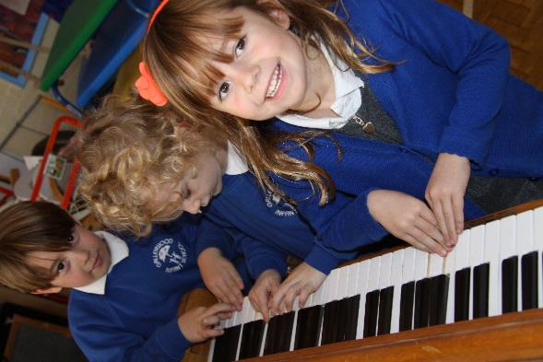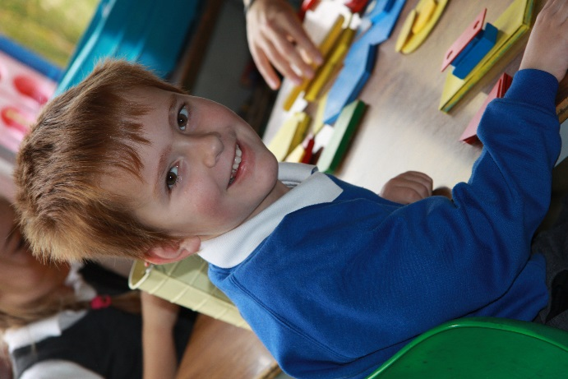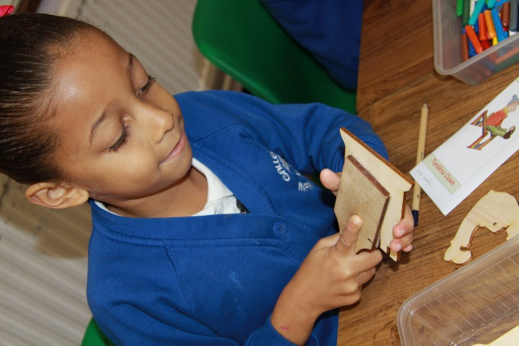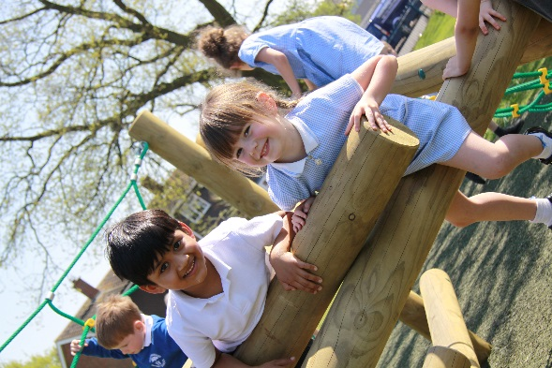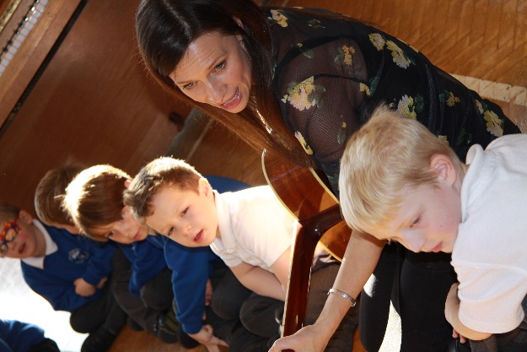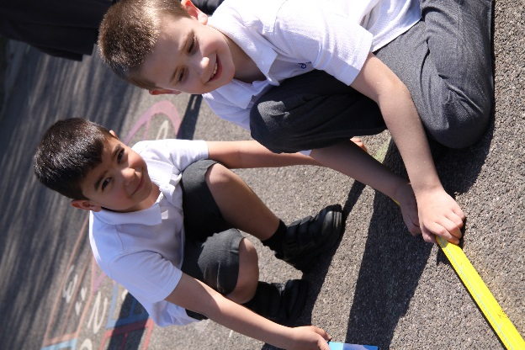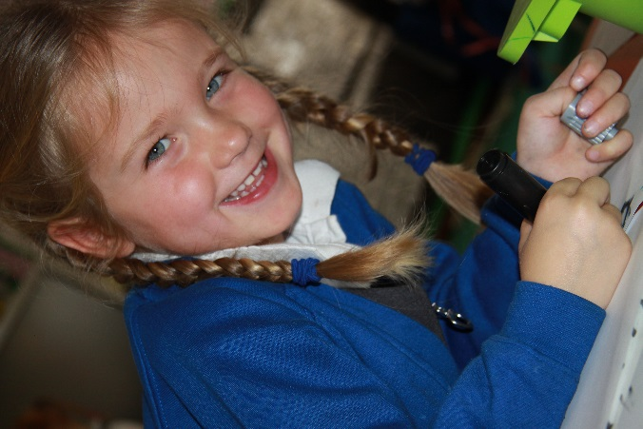

**School Handbook**

**Welcome**



Thank you for your interest in our school. At Galleywood Infant School children enjoy learning due to the rich and carefully planned curriculum experiences we offer within a warm, lively and friendly atmosphere. Achievement in all aspects of life is celebrated and children are encouraged to become confident and caring individuals who make a positive contribution both to the school and to the wider community.

We are fortunate in having a strong team of hard-working and dedicated staff who concentrate on the needs of individual children, supporting and challenging them to do their best.

The twelve members of the Governing Body are fully involved in the work of the school, make frequent visits and operate in partnership with the Staff.

We work closely with parents and would like you and your child to feel actively involved in the life of the school.

We look forward to working with you and hope that with your support and encouragement your child will be very happy and successful here.

We are very proud of our school and school community. We hope that the information in this prospectus will be useful to you in finding out more about Galleywood Infant School. If you have not already visited the school please make an appointment to do so - we would love to show you the school in action!

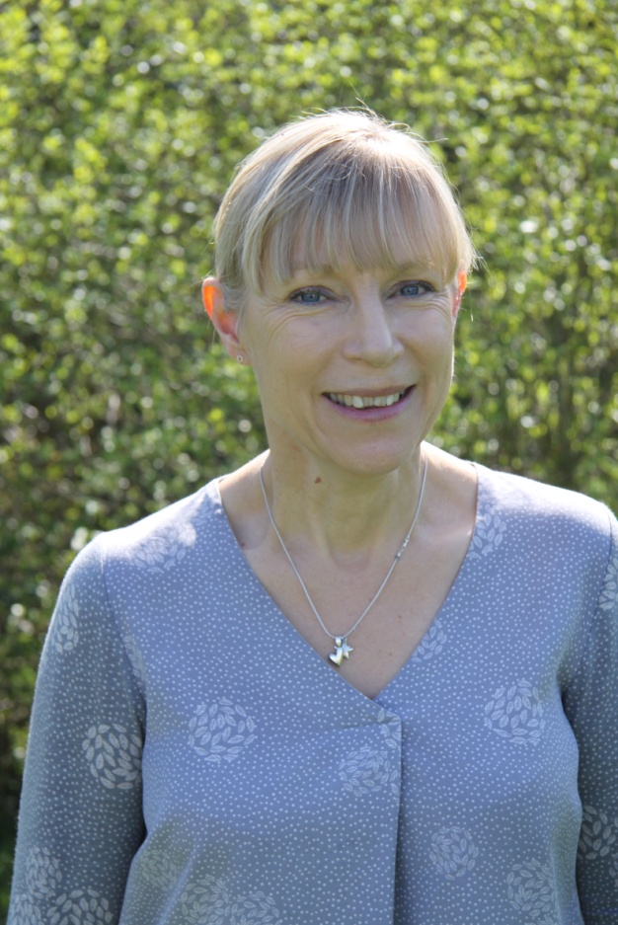

Sarah Manning

Headteacher

**This is what Ofsted said about our school in May 2011 and October 2017**

* *The school is providing pupils with an outstanding quality of education leading to high attainment and excellent preparation for their future education.*
* *A major strength of the school is the excellent care, guidance and support provided for all children, leading to the outstanding outcomes in their personal, social and emotional development.*
* *Children in the Early Years are supported extremely well by all adults because they are acutely aware of children’s needs when they start at Galleywood Infant School.*
* *Observations of teaching and learning, pupils’ work and pupil progress information demonstrate that teachers provide effective challenge for pupils in their learning.*
* *You have created a strong safeguarding culture at the school- a commitment to pupils’ wellbeing permeates the school.*
* *The headteacher, senior leaders and the governing body make an excellent team with a strong focus on continual improvement and ensuring the best for every pupil.*
* *You passionately believe that meaningful parental involvement in children’s education can enhance children’s educational experience and is essential to ensure lifelong learning.*
* *Parents are complimentary about you and your staff and it was evident on inspection that relationships between parents and the school are extremely positive.*
* *Pupils who have low starting points and subsequently need to catch up, benefit from skilful and targeted teaching, which leads to improved self confidence and self-esteem.*
* *Leaders embrace opportunities to develop their own skills.*
* *You offer parents a wide range of opportunities to become fully involved in their children’s education.*

**Contents**

**Page**

* Vision Statement 4
* Finding your way around 5
* General Information 6
* Admissions 7
* School Year Dates 8
* The School Day 9
* Attendance 9
* School organisation 10
* Providing a Safe Environment 10
* Safety in School 11
* Medical Matters 12
* Behaviour 13
* School Staff 14
* Governing Body 15
* Parental Complaints 16
* Our School Meal Catering Service 17
* School Lunches 18
* Milk and Fruit 18
* School Council 19
* GIPA 19
* Community Involvement 20
* Special Educational Needs 21
* Teaching and Learning through each Key Stage 22-23
* Amenities 24
* Communicating with Parents 25
* How Parents Can Help 26
* Charging and Remissions 26
* Clothing 27
* End of Key Stage 1 Data 2019 28

Welcome to Galleywood Infant School

Our aims and vision statement are shared by every member of our staff and Governor team

At Galleywood Infant School we will:

Provide a safe, caring environment in which all individuals feel special and can succeed.

Encourage happy, confident, independent thinkers who respect others and value themselves.

Develop lively and enquiring minds by inspiring children’s natural curiosity and imagination.

Enable children to achieve their best and to set new goals.

Aim to establish effective partnerships between the home and school where parents share in their children’s learning.

Encourage children to become fair, honest and responsible members of the school and the wider community.

At Galleywood Infant School we believe that

learning should be fun, purposeful and challenging.

We aim to develop confident, thoughtful individuals

who take ownership of their learning, persevere in order to succeed

and feel proud of their achievements.

Through inspiring, creative teaching within a rich and engaging curriculum

we aim to equip each child with the skills they need

to be responsible citizens and lead a happy and fulfilling life.

We believe that teamwork and positive partnerships with families, colleagues, governors and the wider community will nurture, support and encourage our children

and prepare them to embark upon future challenges

with enthusiasm, courage, confidence and aspiration.

**Finding your way around**

**Playground**

**and waiting area**

Year 1

classroom

Foundation

Stage

classroom

Foundation Stage

classroom

Hall

Jubilee Quiet Area

Year 2 classroom

Year2 classroom

Year 1 classroom

Boiler

Staff

room

Female WC

Disabled

WC

Boys WC

Head

Teacher

School office

Foundation Stage

Demountable 1

Classroom & cookery area

Demountable 2

YMCA Breakfast & after school club

ICT

suite

Foundation Stage

outdoor

area

Stock

room

Girls

WC

Reading Library

Kitchen

Sensory Room

Reception

Main Entrance

**General Information**

Galleywood Infant School was opened in 1966 to replace the 19th century school in Watchouse Road. The school plays an important part in the life of the community sharing a site with St Michael’s Church of England Aided Junior School.

Our school is spaciously designed with six self contained classrooms including toilets. Our extensive grounds provide excellent opportunities for many types of learning and play in pleasant surroundings.

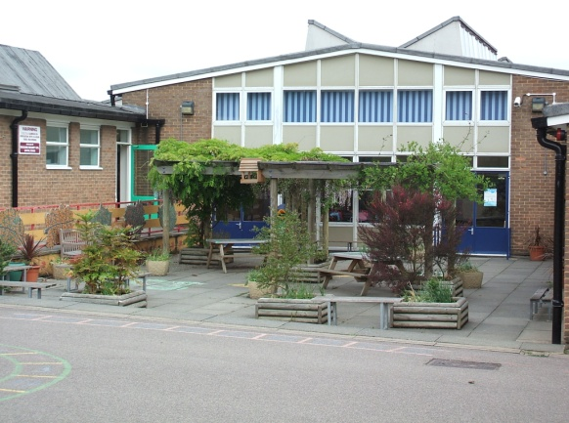 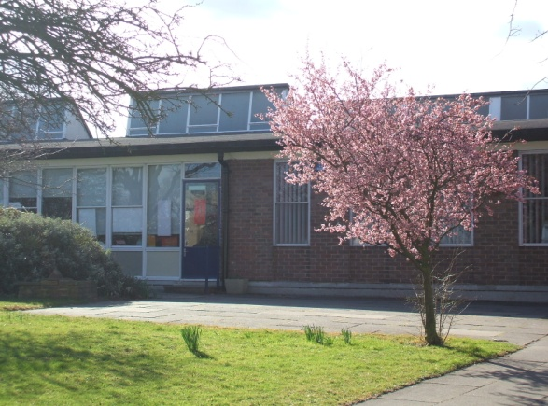

**At Galleywood Infant School we**

* Provide a safe, caring environment in which all individuals feel special and can succeed.
* Encourage happy, confident, independent thinkers who respect others and value themselves.
* Develop lively and enquiring minds by inspiring children’s natural curiosity and imagination.
* Enable children to achieve their best and to set new goals.
* Aim to establish effective partnerships between the home and school where parents share in their children’s learning.
* Encourage children to become fair, honest and responsible members of the school and the wider community.

Galleywood Infant School is an inclusive school giving every child access to all aspects of the curriculum, resources and opportunities.

**Admissions**

Galleywood Infant School provides for the full time admission of all children from the September following their fourth birthday. It is our policy to phase admission to the Foundation Stage over 4/5 days, allowing all children time to settle happily and become familiar with school routines. As dates vary each year the timetable is explained at our meeting for new parents in May.

Parents can request that the date their child is admitted to school is deferred until later in the school year until the child reaches compulsory school age in the term following their fifth birthday.

Parents can also request that their child attends part time until he/she reaches compulsory school age. These children can be collected at 1.15pm until they are ready for a full day. Any requests should be discussed with the school on an individual basis.

Our maximum intake or number intended to admit for each year is 60. In the event of over subscription places will be allocated using the criteria specified in our Admissions Policy which is available in the school office.

We liaise closely with all feeder playgroups and with St Michael’s Junior School to ensure a happy and smooth transition for children joining or leaving our school.

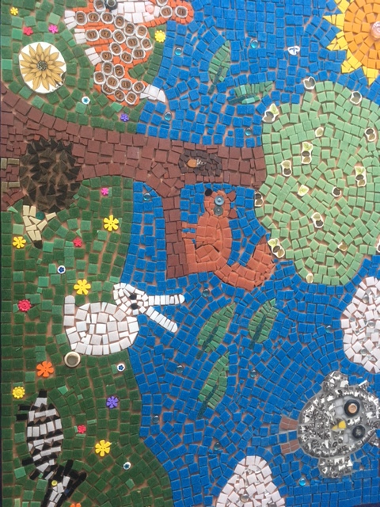

**The School Year - Dates for 2020 – 21**

**2020**

Wednesday 2 September Staff training day

Thursday 3 September School opens for Autumn Term at 8.50am

Thursday 22 October School closes for Half Term at 3.10pm

Friday 23 October Staff training day

**\*\*\*\*\*\*\*\*\*\*\*\*\*\*\*\*\*\*\*\* 23 October – 30 October inclusive Half – Term \*\*\*\*\*\*\*\*\*\*\*\*\*\*\*\*\***

Monday 2 November School opens at 8.50am

Friday 18 December School closes for Christmas holiday at 3.10pm

**2021**

Monday 4th January School opens for Spring Term at 8.50am

Friday 12 February School closes for Half Term at 3.10pm

**\*\*\*\*\*\*\*\*\*\*\*\*\*\*\*\*\*\*\*\*\*\* 15 -19 February inclusive Half – Term \*\*\*\*\*\*\*\*\*\*\*\*\*\*\*\*\*\*\*\*\*\*\*\*\***

Monday 22 February Staff training day

Tuesday 23 February School opens at 8.50am

Friday 26 March School closes for Easter Holiday

Monday 12 April School reopens for Summer Term at 8.50am

Monday 3 May May Day Bank Holiday – School closed

Friday 28 May School closes for Half Term at 3.10pm

**\*\*\*\*\*\*\*\*\*\*\*\*\*\*\*\*\*\*\*\*\*\* 31 May – 4 June inclusive Half – Term \*\*\*\*\*\*\*\*\*\*\*\*\*\*\*\*\*\*\*\*\*\*\*\*\***

Monday 7 June Staff Training Day

Tuesday 8 June School opens at 8.50am

Tuesday 20 July School closes for children for Summer holiday at 3.10pm

Wednesday 21 July Staff training day

**The School Day**

8:50am The children come in to school from 8:50am onwards.

9:00am The school day begins with registration

10:30-10:45am Morning break

12:00-1:10pm Lunchtime

1:10pm Afternoon registration

3:10pm End of the day for all children

Please do not come into school before 8.50am - staff are preparing activities for the day and will not be able to supervise children.

**Attendance**

If children are to benefit from the full educational experience our school provides, good attendance is crucial. It is every parent’s legal duty to ensure that their child attends school regularly. If your child is unwell we require a telephone message by 9.30am on the first day of absence giving the reason.

If you know in advance of an absence e.g. dental appointment, please send a note to the class teacher. If your child will be returning to school we need to know before 9.30 if you wish to book a school dinner.

Parents should **not** takechildren out of school in term time. Under the provision of the Education Act the Headteacher, on behalf of the governing body, will consider leave of absence in exceptional circumstances only. A letter must be provided for our consideration, detailing the special circumstances for the request accompanied by a completed Leave of Absence application form. If the absence is not authorised and the leave is taken anyway, we may refer this to the Education Welfare Service who can issue a Penalty Notice for £60 (if paid within 21 days) **to each parent for each child** taken out of school. The penalty will increase to £120 if not paid on time and if the higher penalty is unpaid within 28 days, The Education Welfare Service may institute legal proceedings against you in the magistrate’s court, for failing to ensure your child attends school regularly.

High attendance is celebrated in whole school assemblies. 100% attendance is rewarded each term with a sticker or small certificate. Our attendance trophy is awarded weekly to the class with the highest % attendance.

Pupil attendance 2018-2019:

* Attendance 95.6% Authorised absence: 3.6% Unauthorised: 0.8%

**School Organisation**

The school is organised into 6 classes with 2 parallel mixed ability classes in each year group.

Children are taught as a class, in small groups and individually. Class sizes vary according to intake numbers but are set below 30 in September of each year in line with Government regulations.

Our class names reflect some of the wildlife on Galleywood Common: Foxes, Badgers, Owls, Hedgehogs, Rabbits and Squirrels.

Each class is well staffed by adults; class teachers and teaching assistants work closely together to support and challenge children in their learning.

Each class has their own midday supervisory assistant who takes them into lunch and works as part of a team to supervise children in the hall and outside.

**Providing a safe environment**

At Galleywood Infant School we believe that children learn best when they feel safe, confident and happy in a secure and friendly environment. We have a number of routines in place to ensure the well-being of children, staff and visitors.

**Bullying and Racism**

The staff and governors do not accept any form of bullying or racism and will act quickly in partnership with parents to deal with any incident that may occur.

**Child Protection**

Our first priority is your child’s welfare. The Headteacher, Sarah Manning, is the designated Safeguarding Children Officer and acts within the Safeguarding Children Policy at all times. Chloe Needham and Rachel Foster are Deputy designated officers. There is a Safeguarding officer in school at all times. Any serious concerns about child safety will be referred to Social Services with prior parental knowledge in accordance with Essex Child Protection Guidelines.

**Arriving at school**

* We support the Safer Journeys to School initiative and actively promote walking to and from school.
* Parking is difficult. There is no space for parents to park on the school premises. Parents and visitors who require a disabled parking space should contact the office in advance. Please do not park in the school driveway as this obstructs the route for pedestrians. Road markings on Barnard Road clearly show where it is unsafe for cars to park. Please also avoid blocking residents’ driveways or using residents’ parking areas.
* Please teach your child to use the school crossing patrol and cross the road safely.
* Dogs, even on a lead, are not allowed on the school site; an exception is made for guide dogs.
* We do not allow smoking in any part of the school grounds.
* If your child arrives after 9.00 am, please report to the school office to sign your child in and let office staff know the child’s lunchtime arrangements.
* Please note: Gates to the playground are locked between 9.10 am and 3.00 pm.
* We ask parents to try and make appointments out of school hours, but understand this is not always possible. If you need to collect your child during the school day e.g. for a dental appointment, please send a note to the class teacher so they know the child will be leaving the class. Sign out at the office so that in the event of a fire drill we know that your child has left the premises.
* If you are going to be late collecting your child at the end of the day please telephone the school. Your child will be brought to the school office to await your arrival.
* In the interests of safety please ensure that the school gates are secured when you enter or leave the playground. Please help us to keep your child and other children safe.

**Safety in School**

Children should not wear jewellery in school. Watches may be worn but these should be named and should be removed for PE. The school and staff cannot be held responsible for any losses.

Jewellery is potentially dangerous in the playground and during PE. In line with Health and Safety advice from Essex County Council we ask parents to ensure that their child removes earrings/ear-studs and leaves them at home, on the days when they have PE. Children will not be permitted to participate in any PE activity or after school sports club whilst wearing earrings/ear-studs.

We have a security system on external doors to prevent unauthorised access. Classroom and hall doors cannot be opened from outside. All staff wear identifying badges in school; visitors and parent helpers are issued with visitor badges upon signing in.

All adults visiting the school must enter through the front door and sign in and out. If you need to bring anything for your child during the school day, please come to the office.

Normally we require written consent for another adult to collect your child unless you have informed us personally or there is an emergency. Any notified variation to collection arrangements is recorded in writing in each classroom.

Essex County Council does not have a personal accident insurance for pupils and parents should make their own arrangements if this is felt necessary.

The school has a Health and Safety Policy, which is in line with County guidelines. All

reasonable precautions are taken to ensure the health and safety of the children in our care. Where appropriate (e.g. school visits, adventurous activities), risk assessments are carried out.

**Medical Matters**

The school has a comprehensive policy regarding illness and medication available on our website or from the office.

It is important that teaching staff are informed of any particular medical problems your child may have and any procedures that should be followed so that we can help the child if the need arises.

If your child has been ill overnight or is genuinely unwell in the morning please do not send him/ her to school. It is unlikely that they will feel fit enough to work and may also spread the illness to other children and staff.

If your child feels unwell in class they will be taken to the office where they can be looked after. If they are not well enough to stay at school we will contact you so that you can collect them.

A school nurse carries out routine medicals and screening checks, making referrals to other health professionals where necessary.

If your child needs to be given medication e.g. antibiotics, during the school day, you may visit the school to give the medicine yourself or you can speak to the office who will issue you with a medication form which will need to be filled in before we can accept any medicines. We can only hold prescription medicines in the child’s name. It may be necessary for the school to seek the advice of the Community Paediatrician before agreeing to this. The school reserves the right to refuse to administer medication.

Children who are asthmatic, diabetic or have other long term conditions and require medication must keep it in the office clearly labelled and with instructions. The children visit the office to use the inhaler or similar as required with supervision. The inhalers are taken with the class on any visits.

Exceptional cases should of course be discussed with the Headteacher.

If your child has an accident in school we will contact you if it is felt necessary. First aid may be administered by the office staff, learning support staff or a member of the MDA team. A note may be forwarded to you if the child has a minor injury which you need to know about, or the class teacher may mention it to you at home time.

Please keep us informed of any changes to your phone number so that we can contact you easily should this be necessary.

**Behaviour**

At Galleywood Infant School we promote good behaviour through positive feedback and praise for children who behave well. A calm environment is vital for good teaching and learning and we believe that parents want their children to be well behaved, polite and considerate. Our behaviour policy sets high expectations, is clearly modelled for children and consistently reinforced by all members of the staff team. We have three key rules which are discussed and expanded by each class at the beginning of the year and displayed prominently in all classrooms:

Look and listen to learn.



Keep yourself and other people safe.





Take care of everyone and our school.

Children are encouraged to take responsibility for their own actions. We do not tolerate any behaviour that involves physical or verbal abuse. Incidents are usually dealt with straight away through discussion, time out or losing favourite activities.

More serious or persistent incidents may involve the class teacher, Headteacher and parents working together to support the individual child.

Our policy for behaviour is available on our website and from the school office.

**Home-School Agreement**

Parents will be asked to sign a Home School Agreement that sets out the expectations for the school, for children and for parents so that we can work together in partnership. The school rules will be introduced and explained to children once they have started school.

**School Staff – June 2020**

**Headteacher** Mrs S Manning

**Deputy Headteacher** Mrs C Needham

**Teaching Staff** Mrs K Fennell

Mrs R Foster

Mrs L Ray

Mrs E Sayers

Mrs A Merry-Bowley

Miss L Bosley

Mrs J Sinnott

Mrs K Coldwell

**Finance & Office Manager** Mrs F Dennis

**Admin Support** Mrs C Gray

Mrs C Reed

Mrs R Brailsford

**Teaching Assistants** Mrs K AllenMrs M-C Beere Mrs A Brown Miss C Copping

Mrs T Diebelius Mrs K Etty

Mrs K Field Mrs G Green

Mrs S Harvey Mrs K Holmes

Mrs S Lacey Mrs L Lay

Mr S Lowman Mrs L Manning

Mrs E McCabe Mrs C Poulton

Miss R Searles Mrs Z Smithers

Mrs A Wade

**Learning Mentor** Mrs T Diebelius

**Cook** Mrs L Bond

**Kitchen Assistants** Mrs S Cordell

Miss S Cole

**Midday Assistants** Mrs T Diebelius (Senior Midday Supervisor)

Mrs A Brown Miss C Copping

Mrs L Dona Mrs K Etty

Mrs K Field Mrs B Fitzsimmons

Miss N Gray Mrs E McCabe

Mrs J Norrington

**Site Manager** Mr J Tee

**Cleaning Staff** Mrs D Linge Mrs D Francis

Galleywood Infant School is an Essex Community School

The department for Schools and Children is based at:

Schools, Children and Families Directorate, PO Box 47, County Hall, Chelmsford, Essex CM2 6WN

**Governors – Sept 2019**

**Chairman** Mrs J Gould

**Vice Chairman** Mr R Holmes

**Members of Governing Body:**

**Staff Governors** Mrs S Manning (Headteacher)

Mrs R Foster

**Associate Governors** Mrs C Needham

Mr P Preston

Mrs F Dennis

**Parent Representatives** Mrs K Bajwe

Mrs C Claydon

Mr R McIlvride

**Local Authority Governor**  Mrs J Gould

**Co-opted** Mr R Holmes (Health & Safety)

Mr M Lewis (Safeguarding)

Mrs E McCarthy

Mrs V Servantes

**Clerk to the Governors** Mrs S Moss

Correspondence for the governors should be addressed c/o School and may be marked private and confidential.

The school governors meet once a term as a full body and additionally once a term for the Learning and Ethos and Resources sub committees.

1. Up to date copies of documents and statements are available on request for inspection in the school office.
2. Please note that the information in this booklet about Galleywood Infant School was correct at the time of printing but it should not be assumed that there have been no subsequent changes affecting the relevant arrangements of some particular matters during the current academic year.

(c) All parents who have a child at our school are eligible to become a school governor when there is a vacancy. Being a governor involves taking a close interest in all aspects of school life. Governors attend at least two meetings a term and work hard for the school. Governors work closely with the Headteacher, Deputy and whole staff team to secure the very best outcomes for children at our school.

**Parental complaints**

It is natural that parents may, from time to time, be concerned about some part of their child’s education or welfare at school. This may, for example, be due to a misunderstanding about the school’s approach to aspects of the curriculum, or about the way we deal with behavioural issues.

We therefore welcome enquiries from parents about these, and other, matters and are confident that, in the vast majority of cases, we can reassure you by explaining our policies and practices, and how they affect your child. Your concern may relate to areas for which specific arrangements exist in law.

You are welcome to see a copy of any of our school policies. We can also provide you with a copy to take away, if you wish, though we have to make a small charge to cover photocopying costs. Please enquire at the school office.

The school aims to work closely with parents and we hope that parents who have any concerns or anxieties will raise these with the class teacher or the Headteacher.

We take concerns seriously and find that matters can usually be resolved quickly and satisfactorily through discussion with the Headteacher or other members of staff.

Generally a matter will be fully investigated and the outcome communicated to the parent in person or by telephone.

If such attempts to settle the complaint informally have failed then the formal stage is reached and parents may contact the Chair of Governors. Details are included in our policy “Working Together, Sharing Concerns”, available for parents on the website.

With a commitment from all involved to resolve any such concerns calmly and rationally, we can work with you to achieve the solution, most appropriate to your child’s interests.

**Our School Meal Catering Service**

MCj02328300000[1]Our school lunches are designed to offer your children something tasty and exciting as well as being healthy, fresh, nutritious and meeting the governments statutory requirements. We believe investing in good quality food and a balanced diet is an investment in our children’s futures.

Children’s favourite foods such as burgers and sausages are still offered within our menus sourcing only high quality ingredients from local, reputable suppliers/butchers. We also include classic favourites such as roast lunches, homemade pies and dishes offering flavours from around the world to try to tempt every palette. Often parents are surprised what their children will eat at school and children eating with their peers are often more willing to try different foods. We encourage children to try/taste new foods often with positive results.

We have a 3 week rolling menu cycle which we change twice yearly and incorporate children’s feedback to ensure we include their favourites. We don’t skimp on the extras either with unlimited access to a full salad bar and homemade brown bread every day. Children also have the choice of organic yoghurt or fresh fruit if they would prefer that to the delicious homemade dessert of the day so there’s always something that every child should enjoy. All food, wherever possible, is cooked from fresh on the premises.

What children eat is an important part of their learning experience and we are committed to educating pupils on food, where and how it is sourced, including growing things in our own school garden! Health and progress stem from eating habits established in early childhood and we want our pupils to experience a whole range of tastes and textures to aid this love of a balanced diet and set them up for their lifetimes. We follow the Government guidelines from the School Food Plan to achieve this.

Our catering and midday staff aim to give your child the best dining experience they can helping and supporting children as necessary to select their food and use cutlery.

Should you be concerned or have any questions regarding allergens, please contact our Catering Manager, Lesley Bond who will be happy to meet with you personally to talk through any products.

From 2014 all Infant School children have been entitled to a free school meal. We would, of course, like every child to enjoy a hot school meal, but we appreciate that some children prefer a packed lunch from home. Your child can of course mix and match their meals according to menu choices. All the children may sit with their friends whether they have a packed lunch or a school dinner.

Children learn through the curriculum the importance of a healthy lunchbox. We do not allow fizzy drinks, peanut butter, sweets, nuts or chocolate bars in lunchboxes and this is reinforced to parents and carers through school newsletters. Staff actively encourage the inclusion of fruit and / or vegetables through lunchtime conversation and sometimes stickers.

**School Lunches**

At Galleywood Infant School we encourage healthy eating whether the children take school lunches or bring a packed lunch from home.

We have our own school kitchen and employ Mrs Bond our cook and her assistants Mrs Cordell, Mrs Pope and Mrs Cole. Meals are prepared daily using fresh ingredients with fresh vegetables, salads and fruit always available. The menus are carefully designed, balanced and comply fully with the Government nutrition regulations. They are displayed in the hall and by the school office; a copy is sent to parents in September and also when we change to a new season’s menu. From time to time we host parent lunches, when you are invited to join us for lunch and have a school dinner with your child.

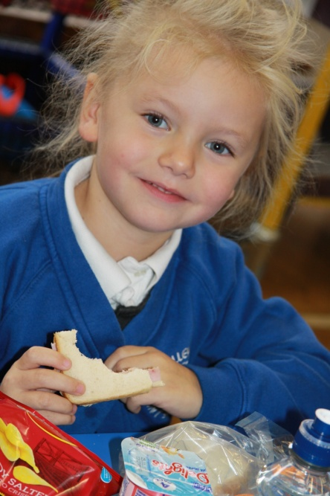 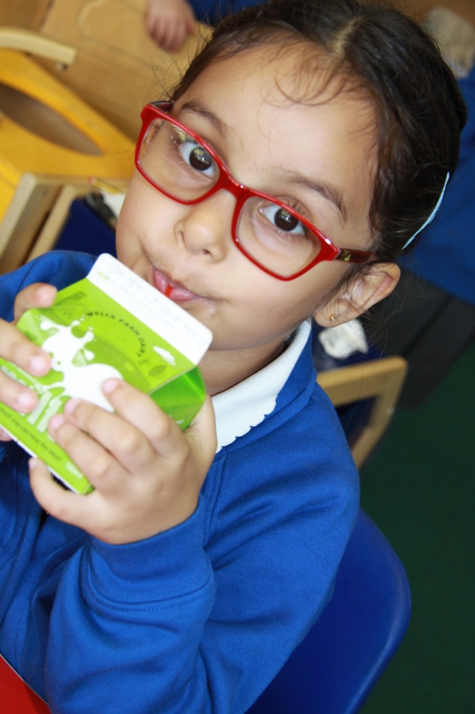 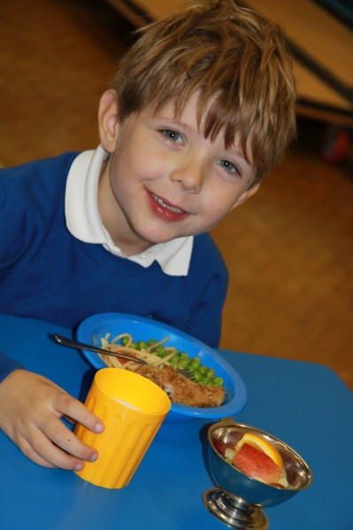

School meals are provided free to all Infant School children. There is still the option for children to choose to bring a packed lunch from home. They sit with their friends, regardless of whether they are having school lunch or packed lunch. The lunch should be packed in a suitable plastic container, clearly labelled with the child’s name. We ask for your support in supplying your child with a healthy packed lunch and request that you do not send fizzy drinks or sweets. As there are children in school known to have nut allergies, no nuts are used in school dinners and we ask parents **not** to pack nuts or peanut butter in lunches.

If you currently receive Universal Credit’s, school will be able to apply for Pupil Premium, an additional funding of £1,320 per pupil which supports children’s learning in the school environment. We will ask all parents to provide us with certain information to enable us to verify if we can claim this funding on behalf of your child/ren.

**Milk and fruit**

If you wish your child to have milk, you will need to register with **Cool Milk** who arrange daily deliveries to school and deal with the administration of orders and payments. You may either telephone **Customer Enquiries** on **0800 321 3248** or log on to [www.coolmilk.com](http://www.coolmilk.com). Children up to the age of 5 will be registered by the school for free milk.

Fruit is provided daily as part of the Government’s NHS Fruit and Vegetables scheme and may include apples, satsumas, pears, bananas, tomatoes, carrots, mini cucumbers or occasionally strawberries! Snacks should not be brought into school for break time.

Research shows that concentration levels are improved by drinking water frequently throughout the day. Children are asked to bring a named water bottle with a sports top each day and refill it as necessary from the water cooler.

**The School Council**

We have an active School Council including representatives elected termly from each class. Every two weeks a class discussion is held to hear children’s views about a particular topic and to collect suggestions to take to the class council meeting. The council discusses suggestions and solutions to issues. There is a School Council notice board in the entrance hall displaying minutes, the next agenda and a suggestion box for children’s ideas.

**Galleywood Infant Parents Association G.I.P.A.**

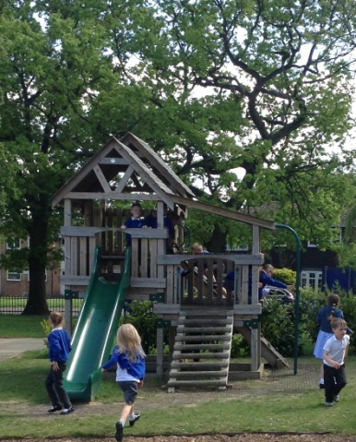We have a very supportive, active parent/teacher association who are generous with their time and energy and contribute hugely to school life through the events and activities they organise. The funds they raise buy extra equipment for the benefit of all the children - our trim trail, pirate ship, play house and new spider climber are popular and used every day!

Every parent is a member of GIPA and we hope that you will be able to support activities and help in planning or running a variety of events.

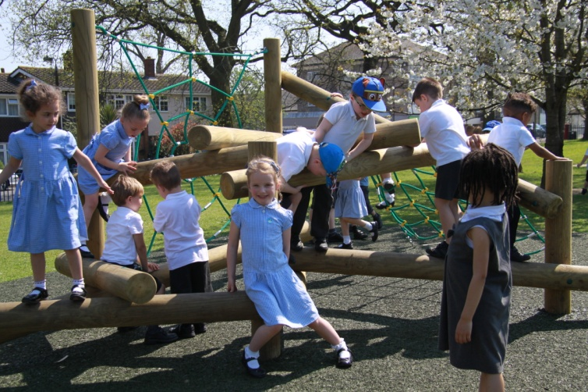

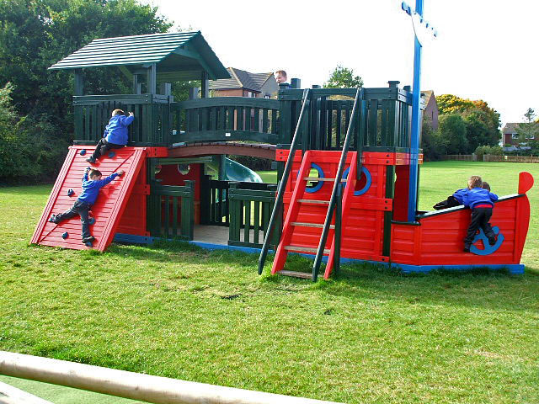

**Community Involvement**

At Galleywood Infant School we foster a strong sense of community within the school through our shared values. We work closely with members of the local community and with local schools to provide our children with an outward looking perspective.

Local pre-school groups visit weekly to have lunch in the hall and use our ICT facilities. Prior to children starting school they are visited in their pre-school settings and/or at home by members of our Foundation Stage team.

We often walk to Galleywood library for a story session and sometimes display work there for everyone to enjoy.

Children are actively involved in raising money for others – recently we have supported:

Broomfield Burns Unit, Sight Savers, Children in Need, Macmillan Cancer Care, The Royal British Legion poppy appeal, Barnardos, Help for Heroes, Diabetes UK and other local and national charities.

We have close links with St Michael’s Church of England Junior School through pupil, staff and governor activities. The school takes part in events such as the Chelmsford Infant Music Festival and Great Baddow High School Festival of Sport with other infant and primary schools.

We have been involved with the Galleywood Parish Council Greening Galleywood project and many children have helped to plant bulbs, trees, hedges and wild flowers in the local area.

The children transfer to St Michael’s in the September following their 7th birthday and a liaison/ induction programme is in place to prepare children and parents for a smooth transition.

Members of the local community use our school for keep fit and short mat bowls.

**Special Educational Needs**

It is the aim of our school to meet the individual needs of every child by offering full access to our broad and balanced curriculum. The needs of most children can be met by adjusting the teaching approach, resources or organisation within the classroom. Extra support with classroom tasks may be provided by a learning assistant, differentiating tasks or providing additional resources to facilitate learning.

Our Special Needs Coordinator (SENCO) works closely with staff to assess and identify learning and behavioural needs at an early stage. Where necessary an Individual Education Plan is designed to help all adults involved with a child to provide an effective and consistent programme of support. We work closely with parents to celebrate progress, share next steps learning targets and explain the strategies we are using. Staff closely monitor a child’s achievements and where necessary seek advice from a range of outside agencies including the school nurse, speech and language therapists, occupational therapists, specialist teachers, the behaviour support team and the educational psychologist.

**Disabilities**

We are a fully inclusive school and children with disabilities are admitted in line with our admissions policy. We work closely with parents/carers and outside agencies to ensure that pupil needs, including access, can be fully supported with the resources we have available.

At three points including our front entrance we have ramps for wheelchair access. We have an accessible toilet for male/ female use. If you require a disabled permit to park in the staff car park please contact the office.

**Teaching and Learning through each Key Stage**

We believe that all children are entitled to an enriched, broad and balanced curriculum experience of the highest quality. Their education must enable children to respond positively to the opportunities and challenges of the rapidly changing world in which they will work and live.

“Every child is entitled to a curriculum rich and varied, challenging and inspiring, which enables every individual to fulfil her or his potential to the highest possible standard, so that all, for the benefit of all, are able to shape their destinies and create a better world.”

Every Learner Essex LEA 1992

The following 10 core experiences are provided each year as a ‘**minimum entitlement’**:

* To perform in a concert to their parents and/or other relatives;
* To take part in a class assembly, shared with parents and visitors;
* To go on an educational visit that involves travelling on a coach;
* To go on an educational visit in the local area;
* To visit St Michael’s C of E Junior School for an assembly or performance;
* To watch a live performance undertaken by visiting professionals e.g. storytellers, musicians, actors or other performers;
* To have the opportunity to work with experts: an artist, musician, performer or author;
* To access 2 hours of high quality, organised physical activity each week;
* To have access to extended provision in the form of after school clubs in KS1.

**The Foundation Stage**

A well-established programme of induction visits enables children to make a happy and confident start to school.

Learning in the Foundation Stage is organised into 7 areas of learning & development:

The prime areas**:**

* Communication and language
* Physical development
* Personal, social and emotional development

The specific areas:

* Literacy
* Mathematics
* Understanding the world
* Expressive arts and design

Children learn through carefully planned activities both indoors and outdoors, sometimes in a guided group with an adult and sometimes through self-chosen play. Children are encouraged to become independent learners, making decisions for themselves and cooperating with others. Through observations and discussion children’s learning is continually assessed and next step targets planned.

**Key Stage One**

At Galleywood Infant School we have designed a thematic approach, carefully planning units of work that link together in a two year cycle. We have incorporated visits and visitors, performances and events to make children’s learning real, relevant and fun! Children and their teachers often use the school grounds as an outdoor classroom.

Topic webs, which give an overview of the half-term’s work are sent home, and published on our website, showing how different subject areas integrate within our themes; we hope these will help parents to support their child’s learning.

Religious Education is taught in accordance with the Agreed Syllabus for Essex schools. Lessons are broadly Christian but also include teaching about other faiths and cultures. We aim to help children grow in spirituality and develop moral values.

A daily act of collective worship takes place with themes taken from the key values for our school.

Parents have the right to withdraw their children from religious education and from the daily act of worship.

**Extra-Curricular Activities**

Staff lead clubs where Yr1 and 2 children can enjoy a range of activities at different times of the year - fun fitness, football skills, computer time, science fun, hand chimes, country dancing, speed stacking, cooking, gardening and skipping games. In addition children have access to Short Tennis, Football, Gymnastics and Basketball with outside providers.

**Amenities**

We are very fortunate to have extensive school grounds, parts of which we share with St Michael’s Church of England Junior School. Our children have a large playground with colourful markings for use in their games.

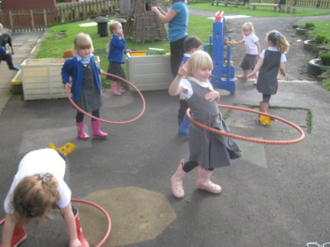

The Foundation Stage classes have access to a secure outdoor area with sand, a play house, fitness trail and roadway. Part of this area is covered by a canopy to allow all weather use.

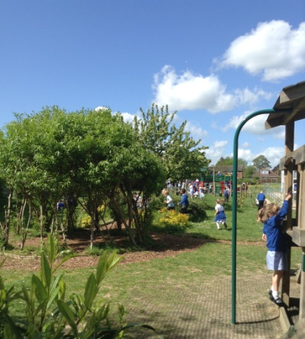

Our wildlife garden a well-established area for playtime games and curriculum work. The trim trail, pirate ship, tree house and spider climber are very popular and encourage children to be active at playtimes.

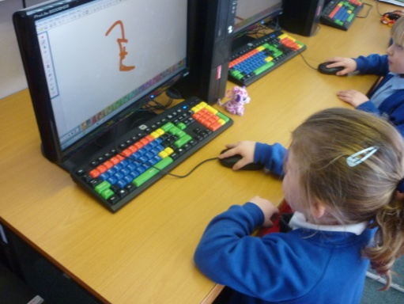We have curriculum computers and laptops in each class, an ICT suite which has 15 PCs and a bank of 16 wireless laptops which can be used in all classrooms or in the library. Every classroom has an interactive whiteboard to make learning memorable and fun! We also have 16 mini ipads populated with a range of educational apps.

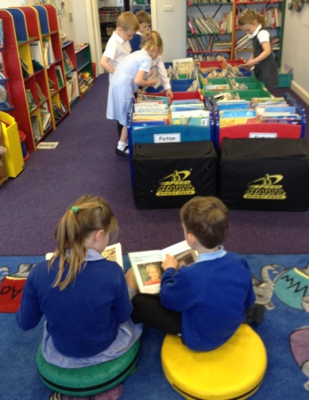

Our library is a cosy space to browse and share a book with a friend. We have listening stations, a range of reading games and story sacks to help our children grow to love books.

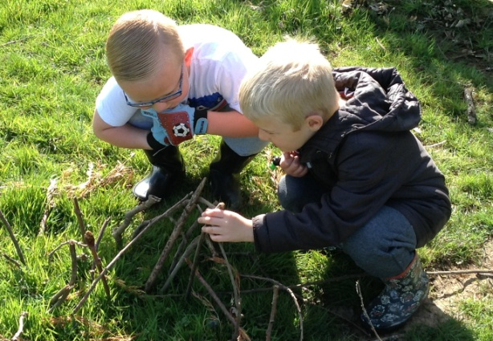

Within our beautiful school grounds Foundation Stage children have a Forest Schools time every week, when they have the chance to build dens, make pictures with natural materials, sing songs and tell stories out of doors.

**Communicating with Parents**

Parents and teachers working together to support children’s learning can have a very positive effect on individual achievement. We aim to keep parents well informed about children’s progress and also about school matters in general. We achieve this in a number of ways:

* Parent consultation afternoons/evenings are arranged on a termly basis, when you may see your child’s work and discuss their progress with the class teacher.
* A full written report is sent to parents/carers in the spring term for Year 1 and Year 2 children and in the summer term for Foundation Stage children.
* Coffee mornings twice a term for parents/carers of children in Foundation Stage classes
* Curriculum afternoons/evenings run by staff introduce you to particular aspects of the curriculum and offer ideas for helping children at home.
* Families are warmly invited to share their children’s work through a class assembly.
* Each half term children take home an outline of the work planned for their year group to help you talk about school activities and perhaps enable parents to loan relevant items to support class work.
* You will receive a newsletter at least every 2 weeks updating you on a range of issues.
* Class teachers and the Headteacher are always happy to talk to you about your child should you have any queries or concerns. It would also be helpful if you could keep us informed of any change in personal circumstances which could affect your child’s performance or wellbeing in school. Sensitive information will of course be confined to those directly concerned. You can make an appointment at the office or by calling in to the classrooms at the end of the school day.
* Our school website provides photos and information about recent events and curriculum work, as well as selected policies and other reference documents that parents might find helpful.
* We also use a piece of educational software, an online learning journal called Tapestry. You will find details on a hand out in your pack which you will need to complete and send back to us so that we can activate your account and generate a password. It is a wonderful way of viewing your child’s achievements.
* The school utilises a system called Call Parents to send messages, information and alerts home to parents via email and text messages. This is a secure system designed for schools. Parents will be registered automatically when their child starts school.
* Another function under Call Parents in Text Messages In, which allows you to contact the school direct via a dedicated phone number. Details for this and Call Parents can be found as a separate hand out in your packs.

**How Parents Can Help**

**At home**

We want you to be closely involved in the education of your child and believe that initial homework begins long before your child starts school by talking, playing games and reading stories. The school has developed a homework policy which is given to all parents when your child starts school.

We encourage you to read regularly with your child at home, talking about the events and characters in a story and predicting what might happen next. Please make an entry in the reading diary as this helps the class teacher to monitor progress.

The school subscribes to online learning resources including Purple Mash, Espresso Home, Bug Club and Abacus Zone. Each child receives personal log in details early in the Autumn term.

**At school**

There are many opportunities for you to become involved in the life of Galleywood Infant School, for example:

* Helping children with reading in the classroom
* Helping with art, craft, cooking, gardening, sewing and other activities on a regular or occasional basis
* Helping with after-school clubs
* Becoming a parent governor
* Supporting the work of GIPA-new members are always welcome
* Supporting performances and assemblies
* Accompanying local walks or longer educational visits

We appreciate the support we receive from parents and friends, but always ensure that a Reference and Disclosure and Barring Service check is carried out.

**Charging and Remissions Policy**

Legislation means that we are only able to ask parents for a voluntary contribution towards the costs of educational visits.

Voluntary contributions are requested from parents towards the cost of those educational visits which would not normally be able to take place without full parental support as the school is unable to fund such activities. In the case of illness or other unavoidable absence, only the cost of entrance fees or the activity charges will be refunded. The school is unable to refund any travel costs.

Where there are personal financial difficulties parents are asked to speak to the Headteacher in confidence. No child is ever excluded from an activity because of a parent’s inability to contribute.

The Governing Body has determined that no charge is made for Art/Craft, Cookery and Technology items. However, during Healthy Schools Week, when children may prepare lunch for themselves and visitors, parents are asked to make a realistic contribution (i.e. £2.00) to cover the cost of the food. Many curriculum events are funded by the school, but occasionally we ask for a contribution towards special activities such as visits from musicians and theatre groups.

**Clothing**

At Galleywood Infant School the children wear school uniform. This promotes equality and a feeling of belonging to a community. We ask our parents to support us in this policy.

The uniform is:

* White or blue shirt/blouse/polo shirt (long or short sleeved)
* Grey trousers, skirt or pinafore dress
* Royal blue school sweatshirt/jumper or cardigan
* White or grey socks/white, grey or navy tights
* Grey shorts or blue/white checked summer dress in summer.

Galleywood Infant School sweatshirts, polo shirts, PE T-shirts, fleeces and legionnaire’s caps and other items are all available to purchase from One Stop Schoolgear, Beehive Lane, Chelmsford. The uniform can be purchased online at [www.onestopschoolgear.com](http://www.onestopschoolgear.com) or by calling 0845 4667208 or visiting the shop Monday to Friday 9am to 5pm and Saturdays 10am – 1pm all year round.

All children are expected to go outside at some time on most days and should therefore have clothing such as hats, scarves and gloves for cold weather.

All clothes should be clearly marked with your child’s name.

Please help your child to become independent by encouraging them to dress or undress unsupervised and buy shoes that he or she will be able to fasten.

Fashion trainers, jelly shoes, sling backs etc. are not suitable footwear for school and can be dangerous in playground games.

**PE kit**

PE is an important part of the curriculum and all children need a PE kit which is kept in a clearly named drawstring bag in the classroom. Your child will need:

* White T shirt (with or without school logo)
* Black shorts
* Black elasticated plimsolls
* A tracksuit for cold weather or jogging bottoms to wear with school sweatshirt

Your child will be asked to bring home their PE bag at holiday times to wash their kit.

**Galleywood Infant School**

Curiosity, learning, friendship

take root and grow



**End of Key Stage 1 data 2019**

Children joining our school have different starting points and each year group includes children with a wide range of needs. Our staff team work with parents and with colleagues to help each child make the very best progress in the Early Years Foundation Stage and to build on this in Key Stage 1.

**End of Year 2**

**The table below shows the school results for the end of Key Stage 1 assessment against the Assessment Framework for 2019 compared to Essex and National outcomes.**

|  |  |  |  |
| --- | --- | --- | --- |
|  | % of children working at the **age related expectation or at greater depth** | | |
|  | **Galleywood 2019** | **National 2019** | **Essex 2019** |
| Reading | **84.5** | **74.9** | **76.6** |
| Writing | **74.1** | **69.2** | **70.6** |
| Maths | **81.0** | **75.6** | **76.6** |

|  |  |  |  |
| --- | --- | --- | --- |
|  | % of children working at **greater depth** | | |
|  | **Galleywood 2019** | **National 2019** | **Essex 2019** |
| Reading | **41.4** | **25.0** | **26.1** |
| Writing | **15.5** | **14.8** | **16.1** |
| Maths | **19.0** | **21.7** | **22.2** |

**Phonics Check at the end of Year 1**

|  |  |  |  |
| --- | --- | --- | --- |
|  | **% children meeting the expected level in phonics at the end of Yr1** | | |
|  | **Galleywood** | **National** | **Essex** |
| **2019** | **86.1** | **81.9** | **81.9** |
| **2018** | **90** | **82** | **84** |
| **2017** | **81** | **81** | **82** |

|  |  |  |  |
| --- | --- | --- | --- |
|  | **% children working at a Good Level of Development at the end of EYFS (GLD)** | | |
|  | **Galleywood GLD** | **National GLD** | **Essex GLD** |
| **2019** | **81.5** | **71.8** | **74.4** |
| **2018** | **76** | **71** | **74** |
| **2017** | **81** | **71** | **73** |

**EYFS**

**The table below shows the school results for the percentage of children achieving the Good Level of Development at the end of the Early Years Foundation Stage.**